Stage 1 Desired Results
ESTABLISHED GOALS  Alaska Content Standards:  A student should understand that history is a record of human experiences that links the past to the present and the future.  A student who meets the content standard should:  1) understand chronological frameworks for organizing historical thought and place significant ideas, institutions, people, and events within sequences  3) recognize different theories of history, detect the weakness of broad generalization, and evaluate the debates of historians  4) understand that history relies on the interpretation of evidence  5) understand that history is a narrative told in many voices and expresses various perspectives of historical experience  6)know that cultural elements, including language, literature, the arts, customs, and belief systems, reflect the ideas and attitudes of a specific time and know how cultural elements influence human interaction  7) understand that history is dynamic and composed of key turning points  8) know that history is a bridge to understanding groups of people and an individual’s relationship to society  9) understand that history is a fundamental connection that unifies all fields of human understanding and endeavor  A student should understand historical themes through factual knowledge of time, places, ideas, institutions, cultures, people, and events.  A student who meets the content standard should:  1) comprehend the forces of change and continuity that shape human history through the following persistent organizing themes:  a) the development of culture, the emergence of civilizations, and the accomplishments and mistakes of social organizations  c) the origin and impact of ideologies, religions, and institutions upon human societies  d) the consequences of peace and violent conflict to societies and their cultures  A student should develop the skills and processes of historical inquiry  A student who meets the content standard should:  1) use appropriate technology to access, retrieve, organize, and present historical information  2) use historical data from a variety of primary resources, including letters, diaries, oral accounts, archeological sites and artifacts, art, maps, photos, historical sites, documents, and secondary research materials, including almanacs, books, indices, and newspapers  3) apply thinking skills including classifying, interpreting, analyzing, summarising, synthesizing, and evaluating, to understand the historical record  A student should be able to integrate historical knowledge with historical skill to effectively participate as a citizen and as a lifelong learner.  A student who meets the content standard should:  3) define a personal position on issues while understanding the historical aspects of the positions and roles played by others  4) recognize and demonstrate that various issues may require an understanding of different positions, jobs, and personal roles depending on place, time, and context  5) base personal citizenship action on reasoned historical judgment with recognition of responsibility for self and others  English Standards  Craft and Structure:  4. Determine the meaning of words and phrases that are used in a text, including vocabulary specific to domains related to history/social studies  NETS- Students  1. Creativity and innovation  Students demonstrate creative thinking, construct knowledge, and develop innovative products and processes using technology.  a. Apply existing knowledge to generate new ideas, products, or processes  c. Use models and simulations to explore complex systems and issues  2. Communication and collaboration  Students use digital media and environments to communicate and work collaboratively, including at a distance, to support individual learning and contribute to the learning of others.  b. Communicate information and ideas effectively to multiple audiences using a variety of media and formats  3. Research and information fluency  Students apply digital tools to gather, evaluate, and use information.  b. Locate, organize, analyze, evaluate, synthesize, and ethically use information from a variety of sources and media  c. Evaluate and select information sources and digital tools based on the appropriateness to specific tasks  6. Technology operations and concepts  Students demonstrate a sound understanding of technology concepts, systems, and operations.  a. Understand and use technology systems  b. Select and use applications effectively and productively | Transfer
Students will be able to independently use their learning to…
1) Tell another a detailed account of the Holocaust, including leaders, camps, and the final outcome
 | Meaning
 | UNDERSTANDINGS  Students will understand that…  1) What concentration camps were like  2) The reasoning Hitler had behind concentration camps  3) That the holocaust was a horrible time in the history of our world  4) Who Hitler was as a leader | ESSENTIAL QUESTIONS  1) Who was Hitler (short life summary)?  2) How did the holocaust relate to World War 2?  3) What were concentration camps?  4) What was life like in the concentration camps?  5) Who were in concentration camps? How many concentration camps were there? Where there camps for specific people?  6) Who were the leaders of the concentration camps?  7) Why did Hitler’s soldiers follow what he said? Did they think it was right or wrong?  8) What happened to the people who were freed from concentration camps? What was life like for them afterwards?  9) What were the results of the holocaust? Survivors and deaths?
 | Acquisition
 | Students will know…  - The main people involved in the Holocaust  - Hitler  - Nazis  - Jews and Jehovah’s Witness  - Gypsies  - Political Enemies  - Disabled  - Poles and other Slavs  - The 6 main camps of the Holocaust, what life was like in these camps, death rates, etc.  - Dachau  - Sachsenhausen  - Buchenwald  - Flossenbürg  - Mauthausen  - Ravensbrück  - The definition of Hebrew/Yiddish words  - Az m’frayggt a shyle iz trayf  - badchan  - bar mitzvah  - bissel  - blokova  - Bris  - burnish  - cauldron  - chaper  - Four Questions  - Gottenyu  - goy  - Haggadah  - Kaddish  - klezmer  - Lublin  - Malach Ha-mavis  - mikvah  - mishigaas  - musselman  - Passover Seder  - schnorrer  - Shabbos goy  - Shadchan  - shmatte  - sthetl  - shul  - Sonderkommando  - Yahrzeit  - Yarmulke  - Yeshiva  - zugangi  - About a variety of victims of the Holocaust  - Men, women, and children’s experiences in the concentration camp, how they got there, and life afterwards  - Why the Holocaust started  - End of a long process of anti-semitism  - Nazis came in power in 1933  - Nuremberg Laws took away all of the Jews’ rights  - How the Holocaust ended  - When World War 2 ended the concentration camps were liberated and the survivors were set free | Students will be skilled at…  1) Identify the main people part of the Holocaust  2) Recognizing Hebrew/Yiddish words and their definitions  3) Discuss the events that led to the creation of the concentration camps  4) Identify the six main concentration camps and listing characteristics of these camps  5) State how the Holocaust ended  6) Give an account of what life was like for the people involved in the concentration camps.  7) State the long lasting results of the Holocaust.

Stage 2 - Evidence
Evaluative Criteria | Assessment Evidence
To evaluate Performance Task #1, I will be using a checklist/rubric that will be made available to students ahead of time to follow. Rubric is listed at the end of Stage 2.  To evaluate Performance Task #2, I will be using a checklist/rubric that will be made available to students ahead of time to follow. Rubric is listed at the end of Stage 2.  To evaluate Performance Task #3, I will be using a rubric/checklist that will be available to students ahead of time. Rubric is listed at the end of Stage 2.  To evaluate Performance Task #4, I will be using a rubric/checklist. Student will receive this ahead of time to follow. Rubric is listed at the end of Stage 2.  To evaluate Performance Task #5, I will be using the rubric that is aligned with the project students choose. Rubrics are listed at the end of Stage 2. | PERFORMANCE TASK(S):  Performance Task #1  Character/Place Description Word Game-  Once students have finished their character/place logs, they must create a word scramble, crossword puzzle, or word find based on their log. The goal would be to give the definitions or description of the character for the word find and crossword so the answers are not just given clearly. If students have a different type of word game that they want to create, this is fine as long as they get it approved by the teacher before starting it.  Performance Task #2  Class Project #1- Holocaust Timeline Bulletin Board  Each student will be given one event to research and write a short summary. The summary should fit on a 3 x 5 notecard. We will make a timeline on the bulletin board and everyone will add their notecard to the appropriate spot on the board.  Performance Task #3  Class Project #2- The Butterfly Project- How We Remember and Honor the Victims  Students will consider why we should remember the victims of the Holocaust, especially the children. They should brainstorm a list of colors, shapes, words, and symbols that represent feelings and emotions associated with either the children of the Holocaust, or how you would like to remember or honor them. Students might also consider including a quote from a poem, story, or song. Students will then complete their butterfly and will hang them up around the classroom.  Performance Task #4  Victim Identity Card Presentations  Each student will be given two Holocaust victims to research. They must then present the victims to the class. This can be done through oral presentation (students can dress like the victim if they desire), powerpoint, video, written expression (song, story, poem).  Performance Task #5  Final Project  Students must choose one of the following topics and follow the rubric for the one they choose. The projects can be presented through a paper, story, powerpoint, presentation, song, webpage, diorama, or through an idea created by the student that is approved by the teacher.  - Give an overview of the Holocaust  - Give a detailed description of one of the concentration camps  - Give a detailed account of Hitler’s life in relation to the Holocaust  - Give a detailed account of what it would be like to be a German Nazi soldier  - Give a detailed account of what it would be like to be a victim in a concentration camp  - Make a diorama (using normal materials, Minecraft, or other type of software) of a concentration camp and write a description to go along with it or present it to the class
Assessment for Chapter Summaries:  Did students give 5 points from each chapter?  Assessment for “L” Journal:  Weekly check to make sure students are adding to their journal. The whole journal will be due at the end of the unit for a final grade.  Assessment for Vocab. Words:  Are they defining the words correctly as we read through the book? Weekly check and final turn in.  Assessment for Vocab. Worksheets:  Have the done two? Were the answers right?  “Who Am I?” Assessment:  Do their answers reflect that they put thought into them and didn’t just rush through them. Did they give reason for each item’s importance?  Character/Place Log:  Do students have at least 3 points for each character and place in their log? Weekly check and due at the end of unit.  Nazi Conscience Assessment:  Were the right/wrong questions answered correctly, and were the what do you think questions answered thoughtfully?  Holocaust Webquest:  Did students answer the questions correctly?  Tour of Auschwitz Assessment:  Did the students answer the questions correctly?  Reading Quiz Assessments:  Did students answer the questions correctly?  Final Written Test Assessment:  Students will get 4 points for each true thing they list that they learned about the Holocaust. They can multiply the number they list by 4 to get their score. | OTHER EVIDENCE:  Chapter Summaries-  Students can write chapter summaries in 5 sentences, bullet points, story form, paragraph form, comic strip, infographic, or poem form. They can change their format for each chapter or decide which they like best or is easiest for them and stick with this form throughout the entire book. These will be due each week.  “L” Journal of the KWL Chart-  We will begin the unit filling in the know, and what we want to learn columns of a KWL Chart. As we progress through the unit, students will keep a journal of what they have learned about the Holocaust. When we get to the end of the unit, we will add this information to our chart. This will also be filled out as we discuss in class. This will help them with their final written test where they have to list 25 things they learned about the Holocaust.  Vocabulary Words-  There are many Hebrew/Yiddish words used throughout the book. Students must define these either with the dictionary definition, using the sentence correctly in a sentence, making a foldable, or using notecards.  Vocabulary Worksheets-  Students have a choice of seven different worksheets that relate to the vocabulary they will be learning throughout the book. They must pick two of these to complete. They can either do these as they read or after they have finished the book and have looked up all the definitions. Some of the options are word finds, crossword puzzles, magic squares, and matching.  “Who Am I?” Self Analysis-  Students will complete this analysis about themselves at the beginning of the unit. It is a worksheet with simple questions, but students should take time to truly evaluate themselves, their personality, and their priorities. They should also try and think historically and respond in a way that would show how they imagined their life being like if they were alive during the Holocaust. After students have answered the questions, they should make a list of necessities they need in their everyday life to allow them to live a comfortable life, be specific in their list, and explain each item’s importance.  Character/Place Log-  As students read through the book, they should take notes on all the characters which they are introduced to throughout the story. There are a list of suggestions on their character log sheet about what they should jot down about each character in addition to their own personal notes. They should also take notes about the different places that are mentioned in the book.  Nazi Conscience Handout-  Students will complete this packet that shows them how the soldiers in Hitler’s Regime were trained and brainwashed throughout the course of their allegiance to him.  Holocaust Webquest-  Students will be given a packet of questions with websites listed. The goal is to use the websites to answer the questions. If students would rather use print resources such as textbooks and encyclopedias they have that option.  Virtual Tour of Auschwitz with Worksheet-  This is also like a webquest where students will go to a specific website and answer questions, but this one relates specifically to Auschwitz.  Weekly Reading Quizzes-  Each Monday students will have a short quiz over the reading that they did the previous week. They will be allowed to use their summaries from each chapter to help them on their quizzes.  Final Written Test-  Students will be required to write down 25 things they learned about the Holocaust. There is really no wrong answers as long as what they put had to do with the Holocaust and is true. This is more of a test to see what they learned throughout the time, rather than being specific in what they learned and studying for a test to get an A because they knew the right material to study.
Character/Place Description Word Game Checklist/Rubric- If full credit isn’t received, students will be given an explanation right below the checklist item.

_____ Game has ten character descriptions (20 points, 2 for each character)

_____ Game has ten place descriptions (20 points, 2 for each place)

_____ Game is written in the form of a crossword, word scramble, word find, or template approved by teacher (5 points)

_____ Descriptions are given as clues to puzzle (10 points)

_____ Descriptions are accurate and true (10 points)

_____ You have made three copies of your game for other students to play. (5 points)

_____ You act as a guide when your group is doing your puzzle and don’t just give them the answers. (5 points)

_____ You participate on “Word Game Day.” (10 points)

_____/85 points

Timeline Event Checklist/Rubric- If full credit isn’t received, students will be given an explanation right below the checklist item.

_____ Your event is on the event you were assigned (3 points)

_____ Your information is true and accurate (10 points)

_____ You give the dates (3 points)

_____ You list important people (6 points)

_____ You list important events within the event (6 points)

_____ You state how the event started (6 points)

_____ You state the results of the event (6 points)

_____ Your information fits on a 3 x 5 notecard (2 points)

_____ You list at least one resource (this can be listed on the back if it doesn’t fit on the front) (3 points)

_____/45 points

Victim Identity Presentation Checklist/Rubric- If full credit isn’t received, students will be given an explanation right below the checklist item.

_____ You researched the two Holocaust victims you were assigned (6 points, 3 for each).

_____ You presented your findings through means of a powerpoint, oral presentation, video, or written expression (song, story, or poem) (15 points).

_____ Your presentation was no longer than 4 minutes and included both Holocaust victims (7 points).

_____ You stated the victim’s names, birthdates, reasons why they were victims, where they were in a concentration camp, date taken, date of death, date of liberation of camp they were in (if they survived the camp, the date they were liberated and the date they passed away), and one interesting fact about the victim (32 points, 2 for each point times 2 for two victims).

_____ You showed one picture of each victim (6 points, 3 for each).

_____/66 points

Butterfly Project Checklist/Rubric- If full credit isn’t received, students will be given an explanation right below the checklist item.

_____ Your butterfly is identifiable as a butterfly (3 points).

_____ Be of presentation quality; neat and reflecting thought and effort (5 points).

_____ Include a short rationale for your butterfly design: 1 paragraph describing why you chose your particular butterfly design and what it represents (15 points).

_____ You made a list of supplies you would need and brought them in on the day we completed our projects (5 points).

_____/28 points

Final Project Rubrics: Each final project is worth 200 points no matter which form they choose. The rubrics are listed below and there are a wide variety of different rubrics so students can make an informed decision on the type of project they want to do. All students will receive additional comments on their rubrics as to why they did or did not receive the total amount of points.

Holocaust Project PowerPoint Rubric

CATEGORY | 4 | 3 | 2 | 1
Content-  Accuracy | All content throughout the presentation is accurate. There are no factual errors. | Most of the content is accurate but there is one piece of information that might be inaccurate. | The content is generally accurate, but one piece of information is clearly flawed or inaccurate. | Content is typically confusing or contains more than one factual error.
Originality | Presentation shows considerable originality and inventiveness. The content and ideas are presented in a unique and interesting way. | Presentation shows some originality and inventiveness. The content and ideas are presented in an interesting way. | Presentation shows an attempt at originality and inventiveness on 1-2 cards. | Presentation is a mere reworking of other people’s ideas and/or graphics and shows little attempt at original thought.
Background | Background does not detract from text or other graphics. Choice of background is consistent from card to card and is appropriate for the topic. | Background does not detract from text or other graphics. Choice of background is consistent from card to card. | Background does not detract from text or other graphics. | Background makes it difficult to see text or competes with other graphics on the page.
Text-Font Choice & Formatting | Font formats (e.g., color, bold, italic) have been carefully planned to enhance readability and content. | Font formats have been carefully planned to enhance readability. | Font formatting has been carefully planned to complement the content. It may be a little hard to read. | Font formatting makes it very difficult to read the material.
Sequencing of Information | Information is organized in a clear, logical way. It is easy to anticipate the type of material that might be on the next card. | Most information is organized in a clear logical way. One card or item of information seems out of place. | Some information is logically sequenced. An occasional card or item of information seems out of place. | There is no clear plan for the organization of information.
Use of Graphics | All graphics are attractive (size and colors) and support the theme/content of the presentation. | A few graphics are not attractive but all support the theme/content of the presentation. | All graphics are attractive but a few do not seem to support the theme/content of the presentation. | Several graphics are unattractive AND detract from the content of the presentation.
Cooperation | Group delegates tasks and shares responsibility. | Group delegates tasks and shares responsibility effectively most of the time. | Group delegates tasks and shares responsibility effectively some of the time. | Group often is not effective in delegating tasks and/or sharing responsibility.
Effectiveness | Project includes all material needed for understanding of the topic. It is a highly effective study guide. | Project includes most material needed for understanding of the topic but lacks one or two key elements. It is an adequate study guide. | Project is missing more than two key elements, making it an incomplete study guide. | Project is lacking several key elements, making it a poor study guide

Holocaust Project Oral Presentation Rubric

Category | 4 | 3 | 2 | 1
Documentation | All information, websites, pictures, artwork, etc. are given credit somewhere in the presentation. | Most of the outside sources are documented in the presentation for all images. | Some sources that clearly state that noncommercial use is allowed without written permission. Sources are documented in the presentation for all “borrowed” images. | Some graphics are borrowed from sites that do not have copyright statements or do not state that non-commercial use is allowed, OR sources are not documented for all images.
Preparedness | Students are completely prepared and have obviously rehearsed | Students seem prepared but might have needed a few more rehearsals. | Students are somewhat prepared, but it is clear that rehearsal was lacking. | Students do not seem at all prepared to present.
Content | Shows a full understanding of the topic. Strong evidence of documentation and research. | Shows a good understanding of the topic. Good evidence of research and documentation. | Shows a good understanding of parts of the topic. Some evidence of research; documentation is weak or missing. | Does not seem to understand the topic very well. Very little or no evidence of research and/or documentation.
Comprehension | Students are able to accurately answer almost all questions posed by classmates about the topic. | Students are able to accurately answer most questions posed by classmates about the topic. | Students are able to accurately answer a few questions posed by classmates about the topic. | Students are unable to accurately answer questions posed by classmates about the topic.
Enthusiasm | Facial expressions and body language generate a strong interest and enthusiasm about the topic in others. | Facial expressions and body language sometimes generate a strong interest and enthusiasm about the topic in others. | Facial expressions and body language are used to try to generate enthusiasm, but do not seem genuine. | Very little use of facial expressions or body language. Did not generate much interest in topic being presented.
Attire | Business attire, very professional look. | Casual business attire. | Casual business attire, but wore sneakers or seemed somewhat wrinkled | General attire not appropriate for audience (jeans, t-shirt, shorts).
Visual Aide | Students use visual aides that show considerable work/creativity and that enhance and support the presentation. | Students use visual aide(s) that shows some work/creativity and that makes the presentation better. | Student uses a visual aide that somewhat makes the presentation better. | The student uses no visual aide OR the visual aide chosen detracts from the presentation.

Holocaust Web Page Rubric

Names:

Topic selected:

LAYOUT DESIGN (25 POINTS POSSIBLE)
Is your web page easy to read?
Is all space used appropriately and effectively with a suitable format?
Do graphics/charts/tables/pictures enhance your web page?
Is navigation clear and logical?

TOTAL FOR LAYOUT DESIGN

CONTENT (25 POINTS POSSIBLE)
Are your ideas effectively communicated?
Are words spelled correctly and is all text within the site grammatically correct?
Are future implications discussed?
Is your writing creative and interesting?
Are there links to appropriate outside resources?

TOTAL FOR CONTENT

ORGANIZATION (50 POINTS POSSIBLE)
At least 1 picture per page
At least 2 web pages
A page for links
Heading for each page
Contact information at bottom, links for each web page

TOTAL FOR ORGANIZATION

SCORE RUBRIC
5 = Awesome
4 = Good
3 = OK
2 = Needs Work
1 = Poor
0 = Not Attempted

OVERALL SCORE x 2
(200 points possible)

Comments:
This is also the rubric if they make a diorama with Minecraft or other software they like.
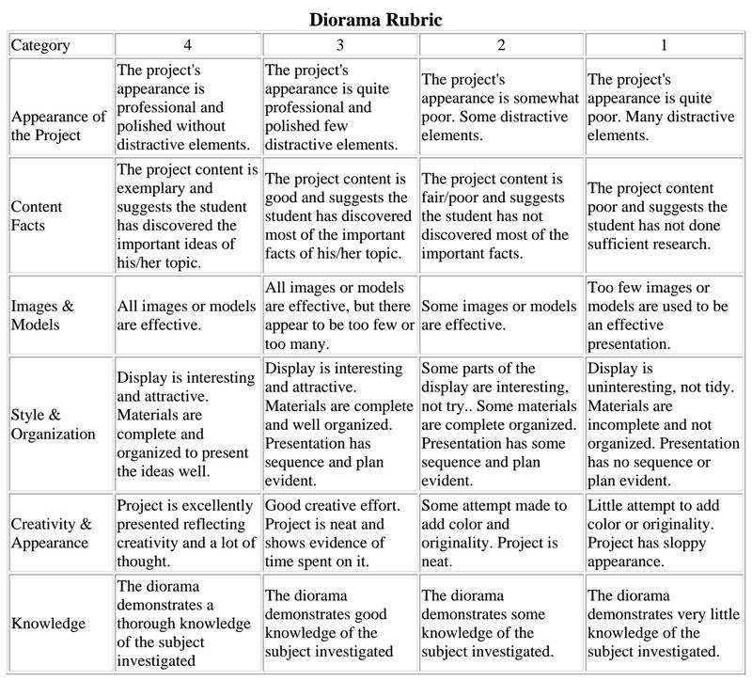

Research Paper Rubric:

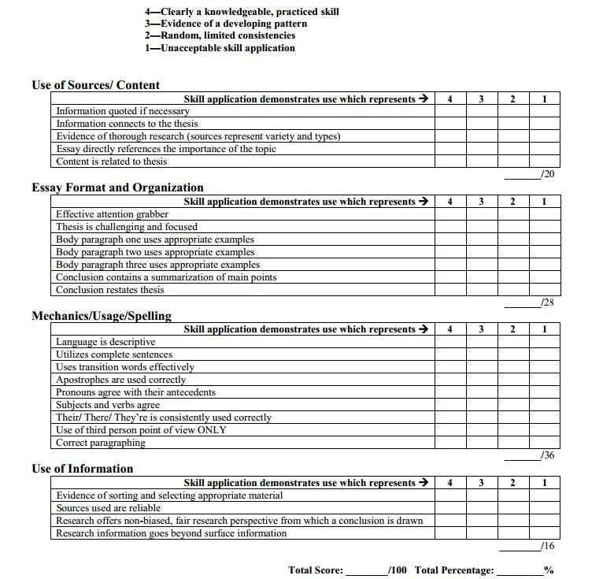

Story Rubric:

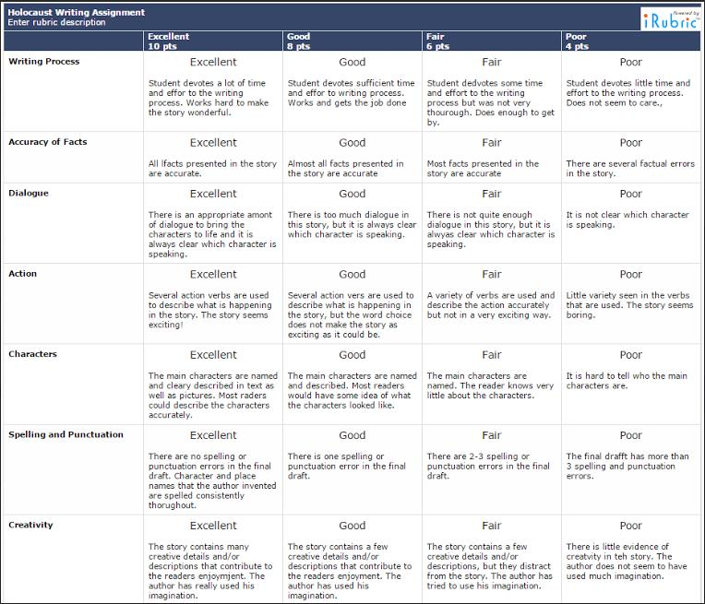

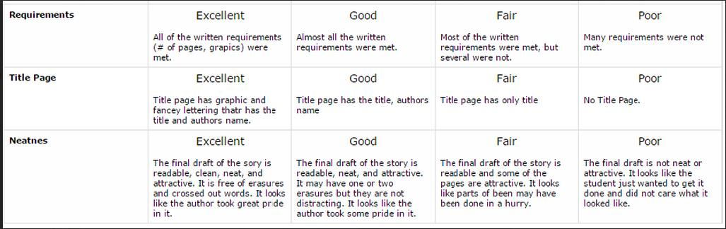

Rubric for Song or Rap:

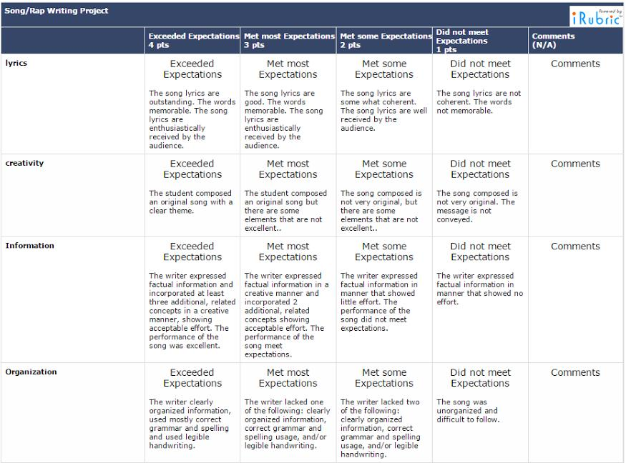

Song/Rap Rubric continued on next page…

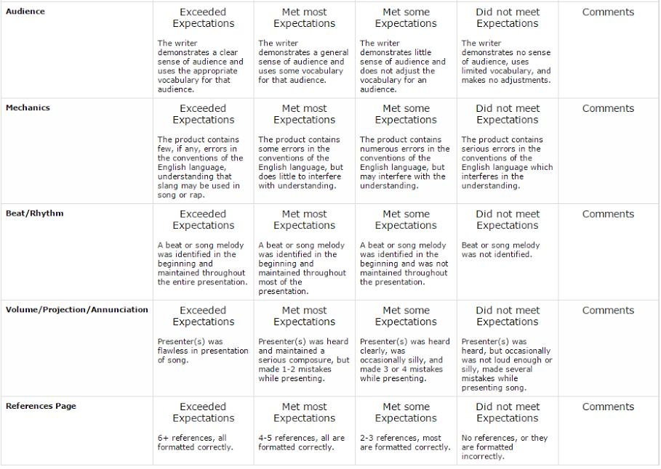

Stage 3 – Learning Plan
Summary of Key Learning Events and Instruction
Week #1

(Day #1) Introduction of Unit

Ask students what they need in life to live comfortably H, R

K and W of KWL Chart- Discuss what students Know and Want to learn about the Holocaust and put it on a piece of butcher paper so when we get to the end of the unit we still have it. W, R, E₂, O

“Who Am I?” Self Analysis- Students will complete this analysis about themselves at the beginning of the unit. It is a worksheet with simple questions, but students should take time to truly evaluate themselves, their personality, and their priorities. They should also try and think historically and respond in a way that would show how they imagined their life being like if they were alive during the Holocaust. After students have answered the questions, they should make a list of necessities they need in their everyday life to allow them to live a comfortable life, be specific in their list, and explain each item’s importance. W, E₁, R, T, O
Discuss Final Project Options and pass out rubrics- Students must choose one of the following topics and follow the rubric for the one they choose. The projects can be presented through a paper, story, powerpoint, presentation, song, webpage, diorama, or through an idea created by the student that is approved by the teacher. W, E₁, E₂, T, O
- Give an overview of the Holocaust
- Give a detailed description of one of the concentration camps
- Give a detailed account of Hitler’s life in relation to the Holocaust
- Give a detailed account of what it would be like to be a German Nazi soldier
- Give a detailed account of what it would be like to be a victim in a concentration camp
- Make a diorama (using normal materials, Minecraft, or other type of software) of a concentration camp and write a description to go along with it or present it to the class

(Day #2) Assignment Expectation Discussion

Group Reading with Chapter Summaries (Must be through Chapter 4 by next Monday)- Students can write chapter summaries in 5 sentences, bullet points, story form, paragraph form, comic strip, infographic, or poem form. They can change their format for each chapter or decide which they like best or is easiest for them and stick with this form throughout the entire book. These will be due each week. Students will break into small groups and start reading and working on their summaries as well as the following: W, E₁, R, E₂, T, O
Start “L” Journals (Checked Weekly, Whole Due Week #6, Day 20)
- As we progress through the unit, students will keep a journal of what they have learned about the Holocaust. When we get to the end of the unit, we will add this information to our chart. This will help them with their final written test where they have to list 25 things they learned about the Holocaust. W, E₁, R, O
Start Character/Place Logs (Checked Weekly, Whole Due Week #6, Day 20)
- As students read through the book, they should take notes on all the characters which they are introduced to throughout the story. There are a list of suggestions on their character log sheet about what they should jot down about each character in addition to their own personal notes. They should also take notes about the different places that are mentioned in the book. W, E₁, R, O
Start Vocabulary Words (Checked Weekly, Whole Due Week #6, Day 20)
- There are many Hebrew/Yiddish words used throughout the book. Students must define these either with the dictionary definition, using the sentence correctly in a sentence, making a foldable, or using notecards. W, E₁, R, E₂, T, O

Continue with “Monday Read” assignments throughout the week.

(Day #3) Introduction of Concentration Camps

Start Powerpoint of Concentration Camps Slideshow- The class will go through a powerpoint of the different concentration camps which I have prepared and we will discuss as we go through them. W, H, O
Virtual Tour of Auschwitz with worksheet- This is a webquest where students will go to a specific website and answer questions, but this one relates specifically to Auschwitz. W, H, E₁
Assign Victim Identity Card Presentations (Due Day #8 of Week #3)- Each student will be given two Holocaust victims to research. They must then present the victims to the class. This can be done through oral presentation (students can dress like the victim if they desire), powerpoint, video, written expression (song, story, poem). W, E₁, R, E₂, T

Week #2

(Day #4) Monday Read

Weekly Reading Quiz over Chapters 1-4- Each Monday students will have a short quiz over the reading that they did the previous week. They will be allowed to use their summaries from each chapter to help them on their quizzes. W, R, O

Student Summaries of Chapters 1-4 Due- Students can write chapter summaries in 5 sentences, bullet points, story form, paragraph form, or poem form. They can change their format for each chapter or decide which they like best or is easiest for them and stick with this form throughout the entire book. These will be due each week. W, E₁, R, T, O
Discussion R, E₂

Give Students Summaries of Chapters 1-4- All students will receive printed out summaries from the internet of the chapters they have read in case they need some refreshing of the reading. T

Group Reading with Chapter Summaries (Must be through Chapter 8 by next Monday)- Students can write chapter summaries in 5 sentences, bullet points, story form, paragraph form, comic strip, infographic, or poem form. They can change their format for each chapter or decide which they like best or is easiest for them and stick with this form throughout the entire book. These will be due each week. Students will break into small groups and start reading and working on their summaries as well as the following: W, E₁, R, T, O
Continue “L” Journals (Checked Weekly, Whole Due Week #6, Day 20)
- As we progress through the unit, students will keep a journal of what they have learned about the Holocaust. When we get to the end of the unit, we will add this information to our chart. This will help them with their final written test where they have to list 25 things they learned about the Holocaust. W, E₁, R, O
Continue Character/Place Logs (Checked Weekly, Whole Due Week #6, Day 20)
- As students read through the book, they should take notes on all the characters which they are introduced to throughout the story. There are a list of suggestions on their character log sheet about what they should jot down about each character in addition to their own personal notes. They should also take notes about the different places that are mentioned in the book. W, E₁, R, O
Continue Vocabulary Words (Checked Weekly, Whole Due Week #6, Day 20)
- There are many Hebrew/Yiddish words used throughout the book. Students must define these either with the dictionary definition, using the sentence correctly in a sentence, making a foldable, or using notecards. W, E₁, R, E₂, T, O

Continue with “Monday Read” assignments throughout the week.

(Day #5) Concentration Camps

Vocabulary Sheets- Students have a choice of seven different worksheets that relate to the vocabulary they will be learning throughout the book. They must pick two of these to complete. They can either do these as they read or after they have finished the book and have looked up all the definitions. Some of the options are word finds, crossword puzzles, magic squares, and matching. (Due Week #5, Day 15) E₁, R, E₂, T, O
Finish Powerpoint of Concentration Camps Slideshow W, H

Discussion R, E₂

Work on Reading, vocabulary, logs, summaries, and L journals W, E₁, R, E₂, T, O

(Day #6) Story and Exploration

Read Rose Blanche, by Roberto Innocenti with discussion- Using the picture book, Rose Blanche, by Roberto Innocenti, do a read-aloud, having the students follow the pictures closely, not just the words. Yes, this book is of low text complexity because it is a picture book, but the storyline is very important to the study of the Holocaust, and it shows such an important point of view, that of a child, that it fits into this study very well; The Devil's Arithmetic is also about children and the Holocaust. H

Holocaust Museum Exploration- Have students explore online Holocaust Museums and write down 4 things they learned in their L Journals H, E₁, E₂, O

Week #3

(Day #7) Monday Read

Weekly Reading Quiz over Chapters 5-8- Each Monday students will have a short quiz over the reading that they did the previous week. They will be allowed to use their summaries from each chapter to help them on their quizzes. W, R, O

Student Summaries of Chapters 5-8 Due- Students can write chapter summaries in 5 sentences, bullet points, story form, paragraph form, comic strip, infographic, or poem form. They can change their format for each chapter or decide which they like best or is easiest for them and stick with this form throughout the entire book. These will be due each week. W, E₁, R, E₂, T, O
Discussion R, E₂

Give Students Summaries of Chapters 5-8- All students will receive printed out summaries from the internet of the chapters they have read in case they need some refreshing of the reading. T

Group Reading with Chapter Summaries (Must be through Chapter 11 by next Monday)- Students can write chapter summaries in 5 sentences, bullet points, story form, paragraph form, or poem form. They can change their format for each chapter or decide which they like best or is easiest for them and stick with this form throughout the entire book. These will be due each week. Students will break into small groups and start reading and working on their summaries as well as the following: W, E₁, R, E₂, T, O

Continue “L” Journals (Checked Weekly, Whole Due Week #6, Day 20)
- As we progress through the unit, students will keep a journal of what they have learned about the Holocaust. When we get to the end of the unit, we will add this information to our chart. This will help them with their final written test where they have to list 25 things they learned about the Holocaust. W, E₁, R, O

Continue Character/Place Logs (Checked Weekly, Whole Due Week #6, Day 20)
- As students read through the book, they should take notes on all the characters which they are introduced to throughout the story. There are a list of suggestions on their character log sheet about what they should jot down about each character in addition to their own personal notes. They should also take notes about the different places that are mentioned in the book. W, E₁, R, O

Continue Vocabulary Words (Checked Weekly, Whole Due Week #6, Day 20)
- There are many Hebrew/Yiddish words used throughout the book. Students must define these either with the dictionary definition, using the sentence correctly in a sentence, making a foldable, or using notecards. W, E₁, R, E₂, T, O

Continue with “Monday Read” assignments throughout the week.

(Day #8)- Victim Identity Card Presentations

Victim Identity Presentations- Each student will be given two Holocaust victims to research. They must then present the victims to the class. This can be done through oral presentation (students can dress like the victim if they desire), powerpoint, video, written expression (song, story, poem). W, E₁, R, E₂, T
Discussion R, E₂

Assign Character/Place Description Word Game- Once students have finished their character/place logs, they must create a word scramble, crossword puzzle, or word find based on their log. The goal would be to give the definitions or description of the character for the word find and crossword so the answers are not just given clearly. If students have a different type of word game that they want to create, this is fine as long as they get it approved by the teacher before starting it. It is assigned now because they can start working on it and continue it as they read the book. (Due Week #6, Day 16) W, E₁, R, E₂, T, O

(Day #9)- Holocaust Powerpoint W, H, E₁, O

Discussion R, E₂

Holocaust Webquest- Students will be given a packet of questions with websites listed. The goal is to use the websites to answer the questions. If students would rather use print resources such as textbooks and encyclopedias they have that option. (Due Week #4 Day 11) E₁, R

Assign Class Project #1 Timeline of Events- Each student will be given one event to research and write a short summary. The summary should fit on a 3 x 5 notecard. We will make a timeline on the bulletin board and everyone will add their notecard to the appropriate spot on the board. (Due Week #4, Day 12) W, E₁, R, E₂, O

Week #4

(Day #10)- Monday Read

Weekly Reading Quiz over Chapters 9-11- Each Monday students will have a short quiz over the reading that they did the previous week. They will be allowed to use their summaries from each chapter to help them on their quizzes. W, R, O

Student Summaries of Chapters 9-11 Due- Students can write chapter summaries in 5 sentences, bullet points, story form, paragraph form, comic strip, infographic, or poem form. They can change their format for each chapter or decide which they like best or is easiest for them and stick with this form throughout the entire book. These will be due each week. W, E₁, R, E₂, T, O
Discussion R, E₂

Give Students Summaries of Chapters 9-11-All students will receive printed out summaries from the internet of the chapters they have read in case they need some refreshing of the reading. T

Group Reading with Chapter Summaries (Must be through Chapter 15 by next Monday)- Students can write chapter summaries in 5 sentences, bullet points, story form, paragraph form, or poem form. They can change their format for each chapter or decide which they like best or is easiest for them and stick with this form throughout the entire book. These will be due each week. Students will break into small groups and start reading and working on their summaries as well as the following: W, E₁, R, E₂, T, O
Continue “L” Journals (Checked Weekly, Whole Due Week #6, Day 20)
- As we progress through the unit, students will keep a journal of what they have learned about the Holocaust. When we get to the end of the unit, we will add this information to our chart. This will help them with their final written test where they have to list 25 things they learned about the Holocaust. W, E₁, R, O

Continue Character/Place Logs (Checked Weekly, Whole Due Week #6, Day 20)
- As students read through the book, they should take notes on all the characters which they are introduced to throughout the story. There are a list of suggestions on their character log sheet about what they should jot down about each character in addition to their own personal notes. They should also take notes about the different places that are mentioned in the book. W, E₁, R, O

Continue Vocabulary Words (Checked Weekly, Whole Due Week #6, Day 20)
- There are many Hebrew/Yiddish words used throughout the book. Students must define these either with the dictionary definition, using the sentence correctly in a sentence, making a foldable, or using notecards. W, E₁, R, E₂, T, O

Continue with “Monday Read” assignments throughout the week.

(Day #11)- The Nazi Conscience

Holocaust Webquest Due

The Nazi Conscience Handout/Discussion (In Class Assignment)- Students will complete this packet that shows them how the soldiers in Hitler’s Regime were trained and brainwashed throughout the course of their allegiance to him. W, E₁, R, E₂

(Day #12)- Timeline Events and Time to Work

Timeline Event Due

Discuss “Butterfly Project” Expectations so they will be prepared to complete them on Week #5, Day 14- Students will consider why we should remember the victims of the Holocaust, especially the children. They should brainstorm a list of colors, shapes, words, and symbols that represent feelings and emotions associated with either the children of the Holocaust, or how you would like to remember or honor them. Students might also consider including a quote from a poem, story, or song. Students will then complete their butterfly and will hang them up around the classroom. W, E₁, R, E₂, T, O
Work on Reading, vocabulary, logs, summaries, and L journals W, E₁, R, E₂, T

Week #5

(Day #13)- Monday Read

Weekly Reading Quiz over Chapters 12-15- Each Monday students will have a short quiz over the reading that they did the previous week. They will be allowed to use their summaries from each chapter to help them on their quizzes. W, R, O

Student Summaries of Chapters 12-15 Due- Students can write chapter summaries in 5 sentences, bullet points, story form, paragraph form, comic strip, infographic, or poem form. They can change their format for each chapter or decide which they like best or is easiest for them and stick with this form throughout the entire book. These will be due each week. W, E₁, R, E₂, T, O

Discussion R, E₂

Give Students Summaries of Chapters 12-15-All students will receive printed out summaries from the internet of the chapters they have read in case they need some refreshing of the reading. T

Group Reading with Chapter Summaries (Must be finished with book by next Monday)- Students can write chapter summaries in 5 sentences, bullet points, story form, paragraph form, or poem form. They can change their format for each chapter or decide which they like best or is easiest for them and stick with this form throughout the entire book. These will be due each week. Students will break into small groups and start reading and working on their summaries as well as the following: W, E₁, R, E₂, T, O

Continue “L” Journals (Checked Weekly, Whole Due Week #6, Day 20)
- As we progress through the unit, students will keep a journal of what they have learned about the Holocaust. When we get to the end of the unit, we will add this information to our chart. This will help them with their final written test where they have to list 25 things they learned about the Holocaust. W, E₁, R, O

Continue Character/Place Logs (Checked Weekly, Whole Due Week #6, Day 20)
- As students read through the book, they should take notes on all the characters which they are introduced to throughout the story. There are a list of suggestions on their character log sheet about what they should jot down about each character in addition to their own personal notes. They should also take notes about the different places that are mentioned in the book. W, E₁, R, O

Continue Vocabulary Words (Checked Weekly, Whole Due Week #6, Day 20)
- There are many Hebrew/Yiddish words used throughout the book. Students must define these either with the dictionary definition, using the sentence correctly in a sentence, making a foldable, or using notecards. W, E₁, R, E₂, T, O

Continue with “Monday Read” assignments throughout the week.

(Day #14)- Butterfly Project
Students will consider why we should remember the victims of the Holocaust, especially the children. They should brainstorm a list of colors, shapes, words, and symbols that represent feelings and emotions associated with either the children of the Holocaust, or how you would like to remember or honor them. Students might also consider including a quote from a poem, story, or song. Students will then complete their butterfly and will hang them up around the classroom. W, E₁, R, E₂, T

(Day #15)- Death Camp Escape

Vocabulary Worksheets- Choose 2 of 7 Due- Students have a choice of seven different worksheets that relate to the vocabulary they will be learning throughout the book. They must pick two of these to complete. They can either do these as they read or after they have finished the book and have looked up all the definitions. Some of the options are word finds, crossword puzzles, magic squares, and matching. E₁, R, E₂, T

Death Camp Escape Powerpoint and Discussion H, R, E₂

Week #6

(Day #16)- Monday Read Wrap Up

Weekly Reading Quiz over Chapters 16-18- Each Monday students will have a short quiz over the reading that they did the previous week. They will be allowed to use their summaries from each chapter to help them on their quizzes. W, R, O

Student Summaries of Chapters 16-18 Due- Students can write chapter summaries in 5 sentences, bullet points, story form, paragraph form, comic strip, infographic, or poem form. They can change their format for each chapter or decide which they like best or is easiest for them and stick with this form throughout the entire book. These will be due each week. W, E₁, R, E₂, T, O

Give Students Summaries of Chapters 16-18- All students will receive printed out summaries from the internet of the chapters they have read in case they need some refreshing of the reading. T
Vocabulary crossword, word scramble, or word find student created due

Fill out the “L” of the KWL Chart- We will get the butcher paper out with our Know and Want to know and add what we Learned to it. W, E₁, R, E₂, O

(Day #17)- Final Written Test: “25 Things I Learned About the Holocaust”- Students will be required to write down 25 things they learned about the Holocaust. There is really no wrong answers as long as what they put had to do with the Holocaust and is true. This is more of a test to see what they learned throughout the time, rather than being specific in what they learned and studying for a test to get an A because they knew the right material to study. W, E₁, R, E₂, O

(Day #18)- Final Project Presentations W, E₁, R, E₂, T, O

(Day #19)- Final Project Presentations W, E₁, R, E₂, T, O

(Day #20)- Final Project Presentations W, E₁, R, E₂, T, O

L Journals Due- We will begin the unit filling in the know, and what we want to learn columns of a KWL Chart. As we progress through the unit, students will keep a journal of what they have learned about the Holocaust. When we get to the end of the unit, we will add this information to our chart. This will help them with their final written test where they have to list 25 things they learned about the Holocaust. W, E₁, R, O
List of Vocabulary with Definitions Due- There are many Hebrew/Yiddish words used throughout the book. Students must define these either with the dictionary definition, using the sentence correctly in a sentence, making a foldable, or using notecards. W, E₁, R, E₂, T, O
Character/Place Logs Due- As students read through the book, they should take notes on all the characters which they are introduced to throughout the story. There are a list of suggestions on their character log sheet about what they should jot down about each character in addition to their own personal notes. They should also take notes about the different places that are mentioned in the book. W, E₁, R, O

Week #7
(Day #21)- Word Game Day
Character/Place Description Word Games were created during the unit. Students will break up into three groups. Each group will get each puzzle that was created to work on as a team. When the group gets a puzzle created by a member in the group, the student who created it will act as a teacher/guide to help the students if they get confused or need help. W, H, E₁, R, T, O

